Appendix B
Equipment used for sampling

Equipment used for sampling

The Versatile air pollution sampler in emission modification VAPS (E) may be configured to measure a variety of emission parameters. The VAPS collects two fine particle samples simultaneously and one coarse particle sample. Gas from the stack was first drawn into an isokinetic sampling probe and then allowed to mix with dried and cleaned ambient air. In the VAPS, effluent is pulled at a rate of about 32 liters per minute (Lpm) reduced about dilution air to minimize water condensation and hence sampling losses; the ratio of desiccated ambient air to stack gas was adjusted to maintain a relative humidity of less than 80 % in the sampling manifold. The sampling manifold was carefully monitored throughout the sampling period for the presence of droplets of water.

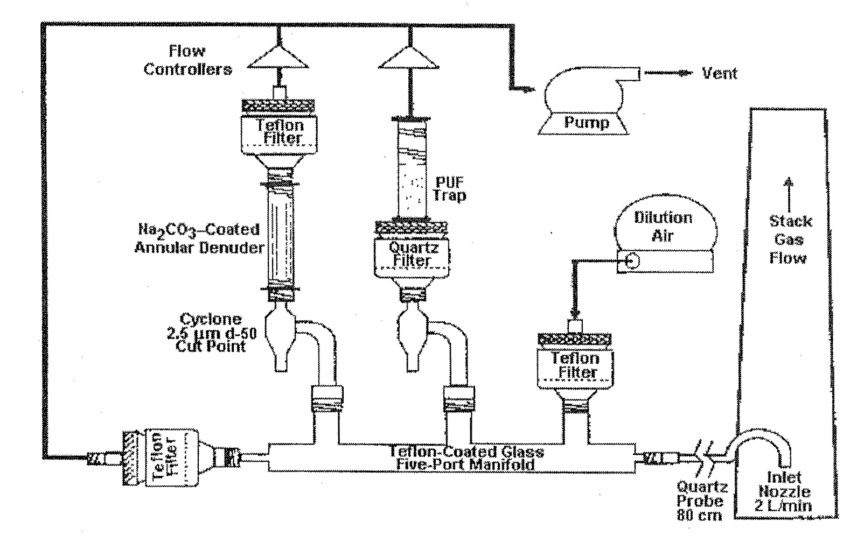

The gas then was passed into the main body of the VAPS, a glass manifold. The gas was split into three airstreams, each pulled through the system by its own pump. The first airstream was pumped at a rate of fifteen liters per minute. This first airstream was passed through a cyclone to separate particles greater than PM2.5 and the fine particles impacted on the filter. This filter may be used to analyze heavy metals.
The second airstream was also pumped at a rate of fifteen liters per minute. This second airstream was passed through a cyclone to separate particles greater than PM2.5 and the fine particles impacted on the filter. This filtered gas, including its organic vapor content, was then passed through a polyurethane foam (PUF) trap, which served to collect efficiently most of the higher molecular weight organic vapors.
The fine particles followed the first two airstreams and impacted on the filters in those arms (the Teflon filter in the first airstream to analyse heavy metals, and the quartz filter and polyurethane foam (PUF) in the second airstream to analyze PAHs)
The third airstream was pumped at a rate of two liters per minute in the direction of the sample extraction. The particles greater than PM10 were separated gravitationaly on manifold, and to the filter of the third airstream particle between PM10 and PM2.5. The Teflon filter in the filter box for mercury analysis. A small part of the third airstream was extracted at a rate of eleven liters per hours to the amalgamator to analyse the three forms of mercury. This sampling was controlled by a special critical nozzle.
The final and smallest part of the third airstream was sampled with the help of a restrictor to a 400 ml large evacuated canister for VOC analysis.

Insulated box: The VAPS body is mounted on a insulated box. The box is temperature-regulated by a combination of a fan for cooling and heater assemblies for heating. The temperature of the box is automatically maintained at a temperature of cca 40ºC.
Pumping System: A single box (for first, second and third air stream and for diluted air) contains four separate pumps, each with its own flow control device and flow meter for setting the flows. The exhaust of each of the pumps is sent through its own respective calibrated dry test meter, which serves to measure the total air passed through that arm.

